https://www.jdoodle.com/embed/v0/66YC
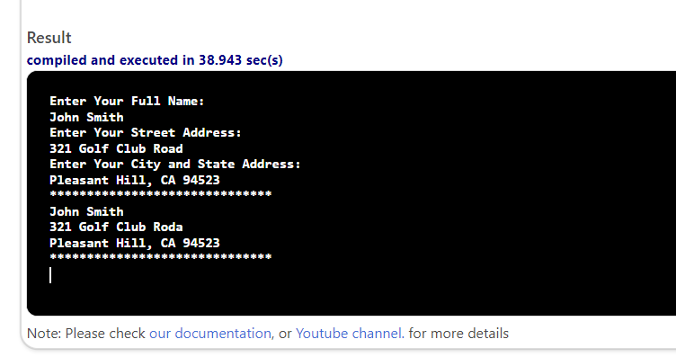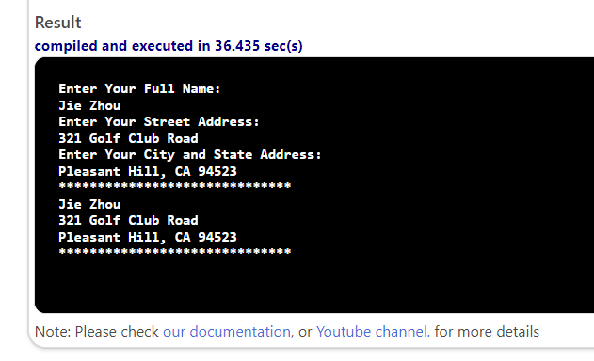

#include <iostream>
#include <string>
using namespace std;
void display() {
for (int i = 0; i < 30; i++) {
cout << '*';
}
cout << endl;
}
int main()
{
string name, address, cityState;
cout << "Enter Your Full Name: " << endl;
getline(cin, name);
cout << "Enter Your Street Address: " << endl;
getline(cin, address);
cout << "Enter Your City and State Address: " << endl;
getline(cin, cityState);
display();
cout << name << endl;
cout << address << endl;
cout << cityState << endl;
display();
return 0;
}

